Code Snippets
- shapeTwoD.h
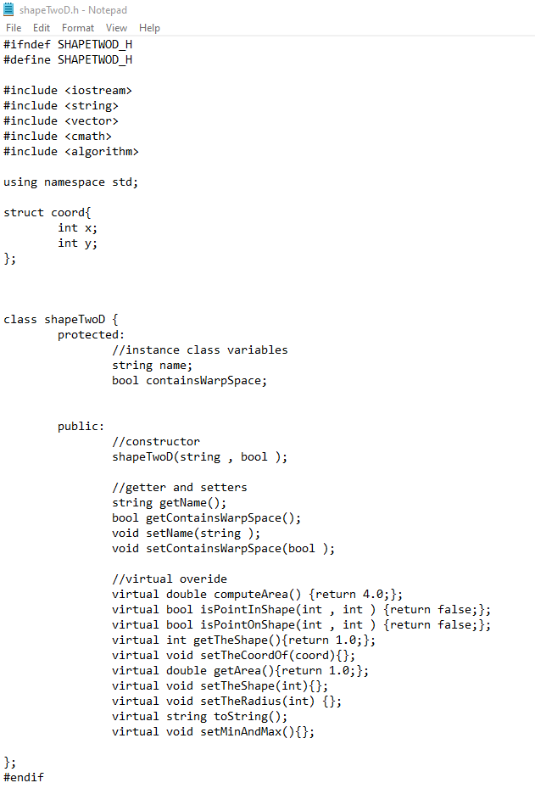
This is shapeTwoD.h. Contains struc coord to encapsulate both x and y values of each points. shapeTwoD superclass with protected variables and public constructors, getters, setters and virtual methods which will be override in the subclasses.

- shapeTwoD.cpp
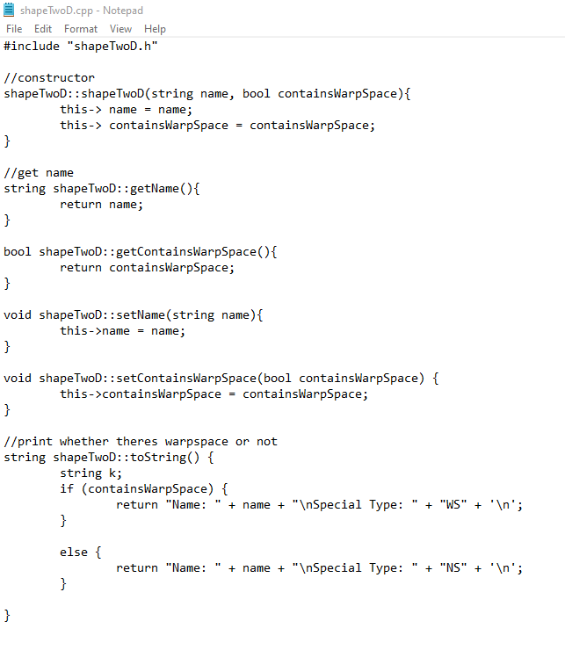
Constructor takes in name of the shape, and a boolean value whether the user key in warp space.
Getter and setters for its protected variables and lastly toString() which prints to console whether there is warpspace.

- square.h, circle.h, rectangle.h, cross.h
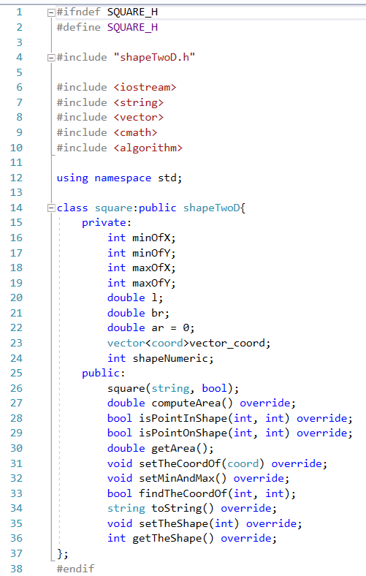
Above is the square header. Contains private variables for the respective shape, and also

- square.cpp, circle.cpp, rectangle.cpp, cross.cpp
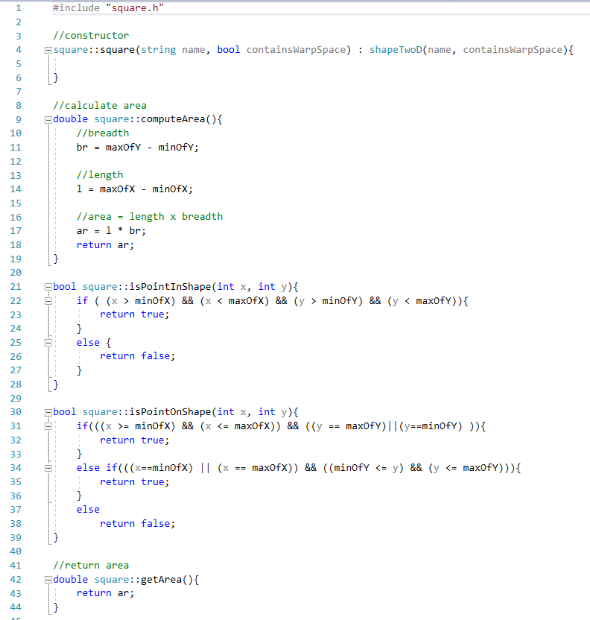
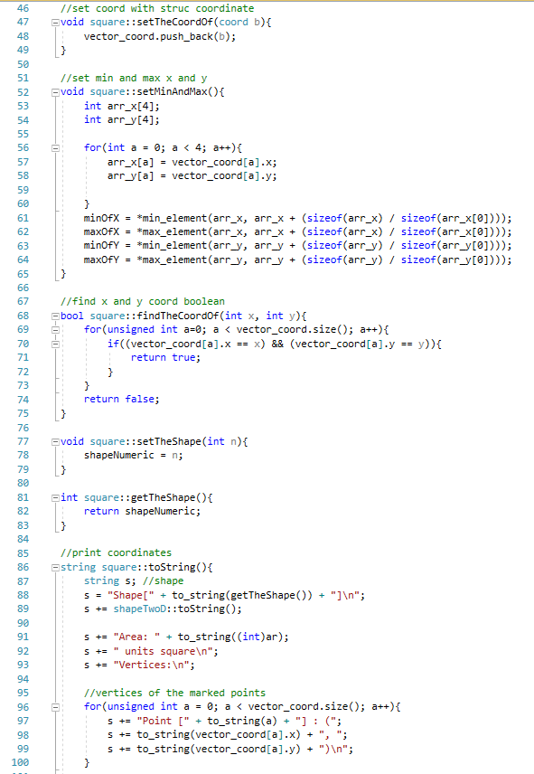
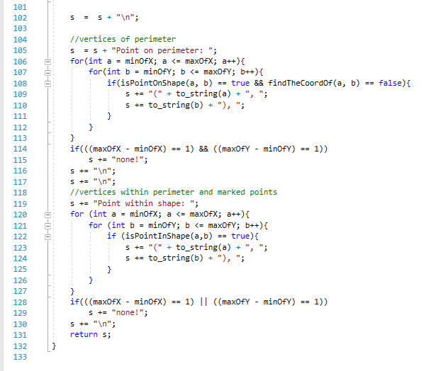
Above is square.cpp. Line 4 is the constructor, inheriting name and containsWarpSpace from its superclass. IspointInShape() function checks whether points lies inside the shape whereas IspointOnShape() check whether points lies exactly on the circumference of the shape. ComputeArea() obtains the area while GetArea() returns the area. ToString() prints the area, perimeter, vertices of the marked points.

- Assn2.h
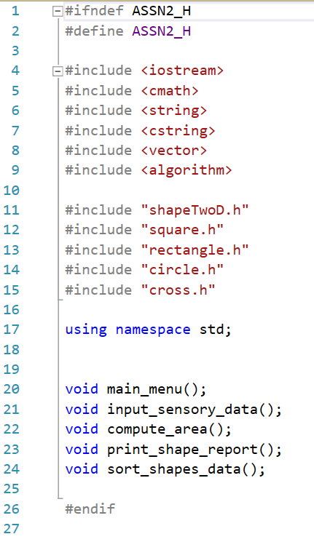
This is the driver file header.

- Assn2.cpp

- 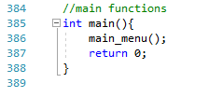
The program starts at line 385 where main function is. The main_menu() function prints out the menu.
- 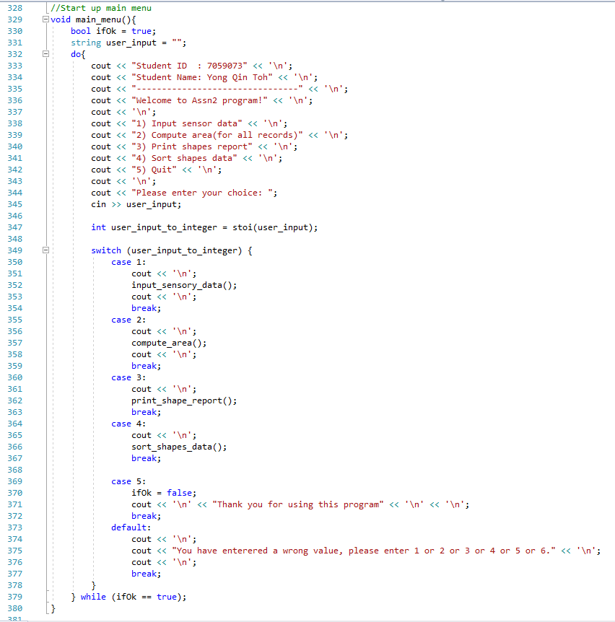
The user is prompted to select either 1 to 5. 1 to input sensor data, 2 for area computation, 3 for shape report, 4 for sorting data and 5 for exit.
- 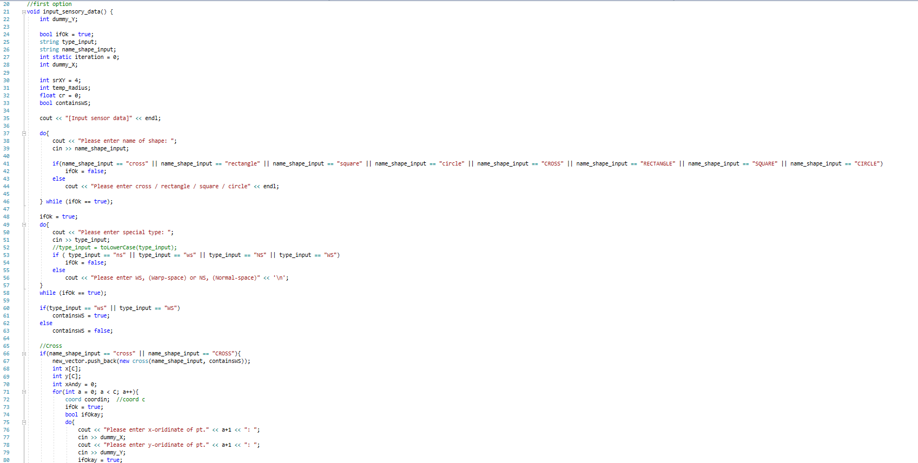
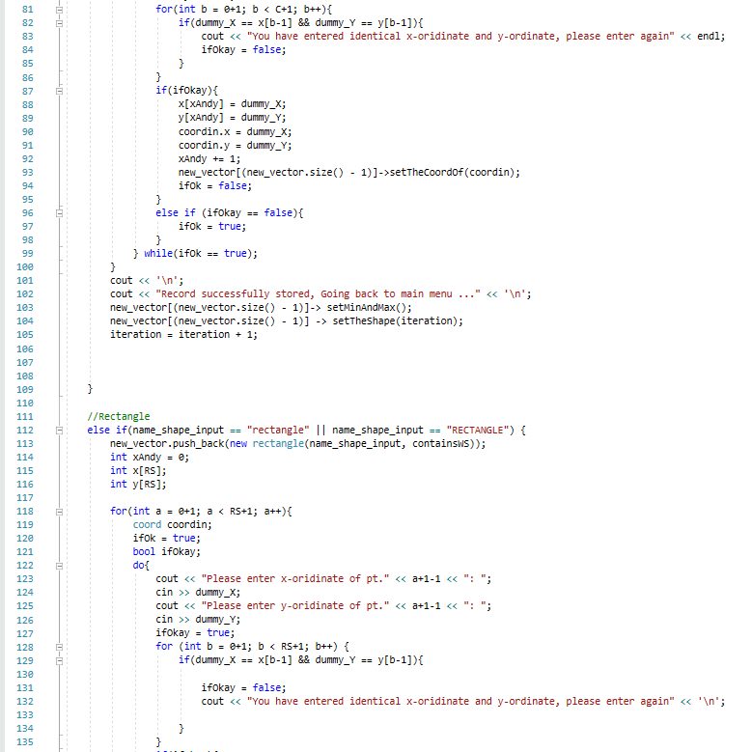
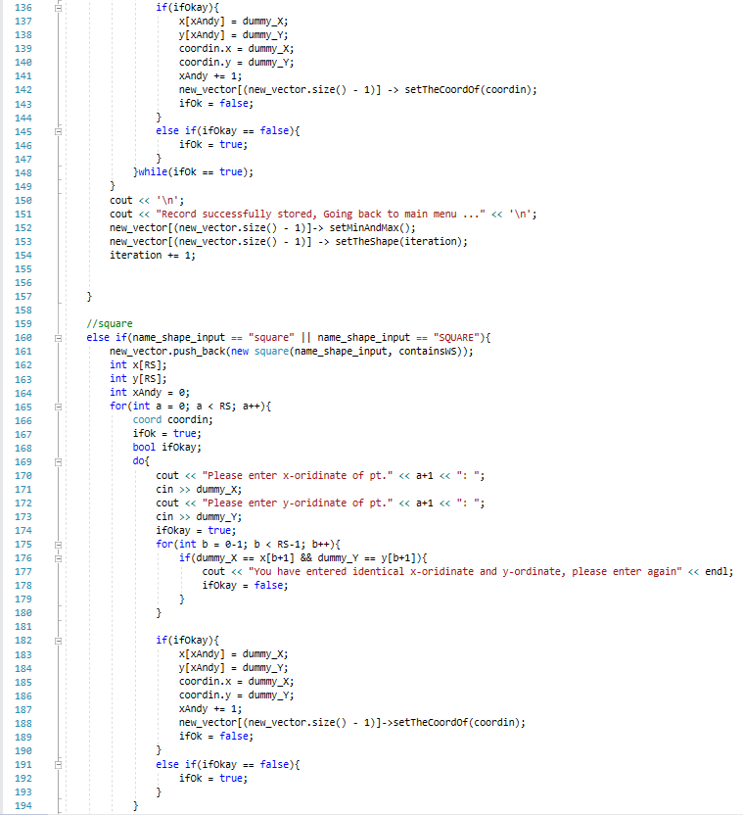
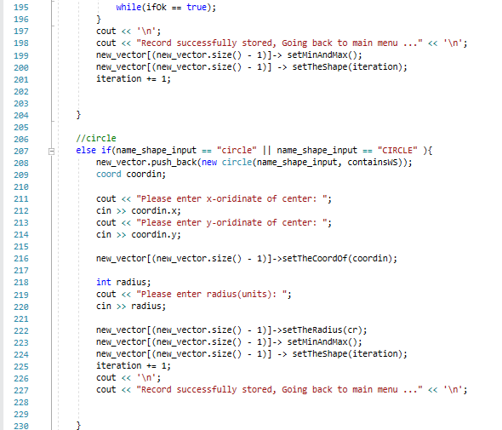
The above codes are for the first option function which is the inputting of sensory data. Users are required to key in their shape of choice, warpspace and marked points.

- 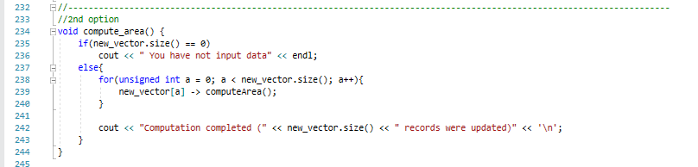
This is a snippet of the 2nd option. It computes the area for whatever shape data is entered from option 1.
- 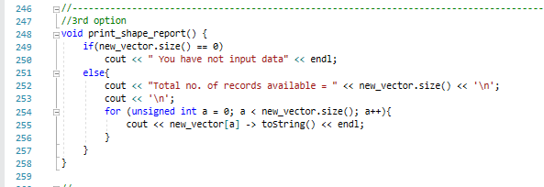
3rd option prints the sumary report such as area, mared coordinates, perimeter.

- 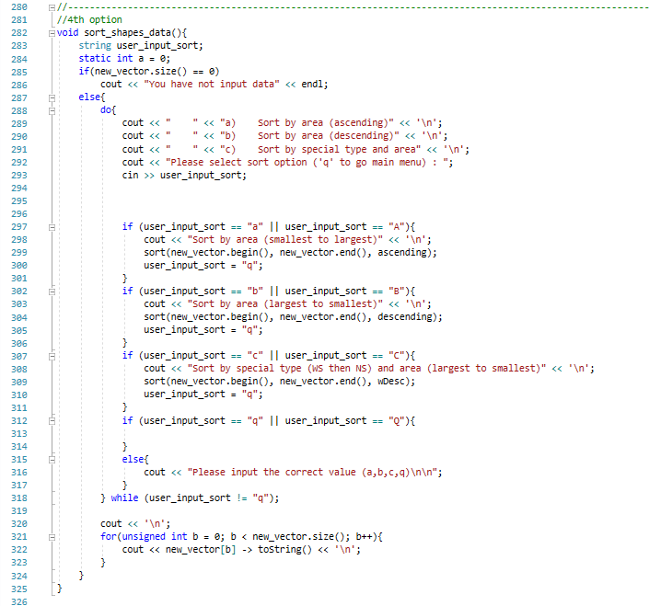
4th option allows users to choose whether to sort area in ascending or descending, and also both area and warpspace by descereasing order.

Reflections
- Assumptions made – all shapes are axis-alligned.
- Difficulties faced – getting all the corner points of the shapes.
- What I have learned – the implementation of classes and inheritance.

